InnoGeo Kft

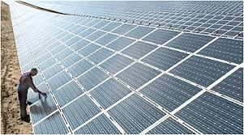

**SOLAR POTENTIAL OF CENTRAL EASTERN EUROPE**

# SOLAR potential OF central Eastern Europe

**The amount of solar radiation reaching the Earth**

The energy formed inside the sun is radiated into the space with a constant intensity according to human scale, and this radiation reaches our planet as well. The solar constant is the numerical value indicating the amount of energy reaching the upper boundary of the atmosphere for a surface unit perpendicular to the propagation direction of the radiation during a time unit and at an average Earth-Sun distance. Its current value is 1,353 W/m2. Since the Earth’s orbit around the Sun is elliptical – one focal point is the Sun – the distance between the Sun and Earth constantly changes, thus the solar constant changes throughout the year between the values 1307 W/m² and 1398 W/m². The beams considered as parallel until the boundary of the atmosphere change into diffuse radiation in the atmosphere. For equipments using solar energy, calculations are made with the sum of direct radiation and diffuse radiation = total radiation, which is called global radiation. These data are related to clean atmosphere.

In the real atmosphere, the direct radiation decreases due to the natural and the civilization’s pollution. The radiation-decreasing feature of the atmosphere is characterized with the opacity factor providing the value of radiation let through by the atmosphere. The average value in an industrial environment is 0.4-0.6, while in a clean, sea environment it is only 0.2.

The solar wind activity is also important to mention (periodic, high-speed solar plasma flow), this however cannot be used for energy purposes, but it can cause serious problems in the communication systems.

**The history of solar energy utilization**

The development of energy-conscious architecture was forced by the lack of combustibles in the 5th century in Greece. A typical Greek house had a south-facing portico with outwork roofing held by pillars. The roof did not allow the summer sun to warm up the rooms, the low winter sun could enter into the building and heated the rooms behind the portico.

The greenhouse horticulture spread quickly in Western Europe from the 16th century. By the end of the 18th century, new solutions were found for the storage of the heat in greenhouses. The heat of the sun was stored in brick walls for the cooler night-time, or the warm air was stored in an extra chamber and fed back into the greenhouse by convective flow during the night. South-facing glasshouses attached to the houses became popular in the 19th century England, where people kept their ornamental plants. Occasionally, these were attached to the residential building through doors and windows. They could significantly contribute to the heating of the residential building during spring and autumn.

The energy-conscious architecture of the ancient times reappeared in the 19th and 20th century, but these were rare occasions and served only for demonstration or experimental purposes.

The largest solar energy programme started in 1938 and lasted until 1962 with a few years of pause. The main reason of the programme was the immense energy consumed by the US residential buildings, exceeding the energy consumption of the complete industry. The partial replacement by solar energy could have a huge economic importance.

The first south-facing solar house had a collector area of 40 m2on its roof. The water heated by the collectors was pumped into the 70 m3-tank in the basement. The air heated by the tank was led into the living area by ventilators. The pump and the fans were operated from the electric network. When the water temperature of the collectors dropped under the temperature of the tank, the system would automatically empty. This eliminated the risk of the collectors to frost, and there was no heat loss due to the cold temperature outside.

*Edmund Becquerel,* the father of Nobel Prize winner *Henri Becquerel* discovered the Becquerel effect (1839). He discovered that when one of two electrodes immersed in an electrolyte is illuminated, a potential difference arises between the electrodes. The effect can be used – in theory – for transforming light energy into electricity. *Charles Fritts,* an American inventor made the first solar cell at the end of the 1880s, Its efficiency was lower than 1%. After the discovery of quantum physics and photoelectrical effect, some inventors began to produce solar cells at the beginning of the 1930s, but the bad efficiency of the selenium solar cell did not motivate further researches.

The oil industry started to boom after World War II all over the world, while the solar energy industry began to develop in some energy-poor countries (e.g. Israel, Japan). Luz International built 8 solar energy plants in California between 1984 and 1990. These were parabolic trough plants with a total capacity of 355 MW.

The flat solar collectors are the most common means of solar energy utilization, these are used for hot water production and auxiliary heating of private houses and public buildings. The EU member states have a leading role in the construction of solar collectors, the leader being Germany (becoming No. 1 in the world in the construction of wind power plants). The use of solar energy is a government objective in Germany, the Netherlands, Denmark, Switzerland and Austria.

The integrated, “complete building” approach is gaining more and more ground in solar architecture. This means that active building equipments are used beside passive architectural elements for a better use of solar energy in order to minimize or eliminate the traditional energy supply demand. Multifunctional use of certain elements, facilities is a common feature of these buildings. For example, the heat of flat collectors is used for hot water production and for auxiliary heating purposes in the low-temperature central heating system. Solar collectors can serve as a protecting roof, roof covering or sunblind as well.

**Solar energy potential**

The amount of usable solar radiation is influenced by the inclination angle and orientation of the equipment, and by the intensity and quantity of total solar radiation. The intensity and duration of solar radiation is measured at weather stations. The radiation intensity is measured in units, for radiation energy of 1 joule on a 1-m² surface perpendicular to the Sun's rays in 1 second. Its unit is W/m2. The irradiance is the product of the intensity and duration measured in J/m2.

Global radiation maps can be made in three ways. The first traditional method is the interpolation of values measured at the weather stations; the second is the analysis of METEOSAT satellite images; and the third is the numerical modelling. The duration of radiation or insolation is a measure of solar radiation energy recorded during a given time (hour, day, month or year). The threshold of solar radiation is 200 W/m2 of direct radiation. Insolation is recorded with the Campbell-Stokes recorders.

Winter and summer usability varies due to the geographical situation of the countries (an external temperature below frost-point comes with a relatively high radiation energy yield, fact that influences the efficiency of solar collector equipments). Accordingly, solar energy can be used only to limited extent during the winter.

**Passive utilization of solar energy**

The passive utilization of solar energy does not imply any special equipment. This method can be exploited in the architecture.

Every building uses the energy of the incoming solar radiation at different efficiency levels. This aspect was more or less considered during the placement of buildings into the environment. An important aspect of passive utilization is the climate of the actual area. An area with tropical climate close to the equator enables better energy utilization than northern countries, where heating is necessary during the summer, or e.g. in Hungary, where there is only a small amount of solar energy available in the winter, but a high amount in the summer. The architecture of past decades did not exploit this possibility, resulting in badly oriented buildings and small window surfaces, and a small amount of usable solar energy and higher heating costs. At the same time, some buildings are overheating in the summer, reducing the comfort of the owners. (Kuba & Gyurcsovics, 1994)

**The aim of passive solar energy utilization**

The facts mentioned above show the aim of passive energy utilization: the building shall not overheat in the summer, but it should be able to use the solar energy in an ideal way by the given climate conditions. The following figure shows that the quantity of energy collectable with solar collectors and cells depends on the orientation and the inclination settings of the equipments. South orientation is the most favourable for energy utilization. The ideal inclination value depends on the time of operation. In case of an operation during all year, by considering the average radiation data for Hungary (N. 48˚), the ideal angle is 43.5 ˚. In the summer, this value is 18.5 ˚ due to the different altitudes of the sun, and 76.2 ˚ in the winter. The generally used angle is 30-60°.

Conditions of passive energy utilization:

• High number of sunny hours

• Solar radiation shall reach the building

• The building shall be able to utilize the radiation

• It is important for the building to be able to store the heat and to transfer it back into the space to be heated.

In case these conditions are not fulfilled, the building cannot be design for passive solar energy utilization. (Húsvéth, 2007)

The following points shall be considered in the design phase from the point of view of passive solar energy utilization:

• on rural level

- the ideal route of roads for the proper orientability of the buildings,

- consideration of insolation during the definition of distances between buildings,

- proper plants for shading that can protect the buildings from strong radiation in the summer,

• on building level

- the favourable orientation,

- design of a proper layout and mass form according to orientation and for the minimization of heat losses,

- ideal dimensioning of glassed surfaces,

- consideration of passive utilization during the selection of the materials for the building structures (e.g. proper heat storage of walls)

**Possibility of passive energy utilization**

Its primary task is the use of solar energy in buildings for heating purposes in “energy poor” seasons. Winter is quite long in the variable zone, thus the passive utilization of solar energy is of importance during spring and autumn seasons. The simplest method is the placement of well-sized insulating windows on the southern side of the building, and to design the living areas for the southern side. This solution is available for everyone during the construction of a new house, without extra costs. It is important, that passive energy utilization is quite expensive and difficult in case of existing buildings. (Szabó, 2005)

**The design of passive solar energy utilization**

The most important aspects are the proper choice of the lot, the ideal size and form of the house, the proper orientation, the good placement of interior spaces and the proper technical parameters of structural elements (walls, roof, ceiling, doors and windows), the good heat storage of structures, and finally, the proper use of the building.

Solar radiation modifies the external structure and the energy circulation of doors and windows. The primary source of passive utilization is the energy coming through the frontal windows. This can reduce the energy loss of wall structure by 25%. According to experiences and measurements, the common simple solutions (thick curtains, blinds, shutters) can significantly reduce the energy loss of windows during the night (25-50%). Solar radiation can affect the energy flow of glass structures on average cloudy winter days as well. The heat loss of northern windows on a sunny day can be reduced by 15%. Southern windows have mostly a positive energy balance, in some cases, the energy gain exceeds the energy loss of the same period. The alternatives for the reduction of heat loss mentioned above (curtains, blinds etc.) can shift the balance towards positive values. Windows with modified optical and thermal features can have a different energy flow and balance, a potential low heat transmission coefficient can result in a negative balance even on a south façade due to the lower solar factor of the glass. Accordingly, northern windows are generally the reason for significant heat losses. This can be twice or five times higher than the heat loss of well-insulated structures. The relevant parameters of eastern and western windows are almost similar to properly insulated walls. Southern window structures gain definitely the most energy of buildings. (Szabó, 1986) The building service and energy literature suggests the proportions and orientation of windows for energy saving purposes. The suggested window surface for northern windows is of 5%, 60% for western and eastern, and 35% for southern windows. (Szalay:2006). Unfortunately, the architects do not yet subordinate design to the protection of the environment and energy efficiency, thus these values are often not considered. In case of external doors and windows, the proportion of differently orientated window and wall surfaces is of great importance from the point of view of the total heat loss of the building.

The quality of doors and windows is the second most important aspect. The energy flow of window structures is the result of three independent physical processes. Heat transmission, transmission of solar energy, and filtration. The energy flow resulting from the solar radiation through the windows and glass surfaces and the difference between the interior and exterior temperature can be calculated without considering the energy demand of the heating of supply air.

This can be a positive or negative number; positive values indicate a gain, and negative values a loss of energy. The technical parameters of doors and windows are important as well from the point of view of the passive utilization of solar energy. The U-value of traditional doors and windows is 2.8, their solar energy transmittance is of 77%. Modern, 3-layer windows have a better heat insulation capability - k= 1.1, but their g-value is only of 57%, or they are filled with gas between the layers (e.g. argon) k=0.7. Winter insulation can be improved in different ways, such as the soft metal coating of glasses that does not modify significantly the transmittance (allegedly), or the reflective surface coatings for summer thermal protection that can reduce the transmittance of the glass to 10%.

In order to keep the thermal energy that arrived in the building through the windows, and to utilize it when the sun is not shining, the building must have a heavy structure and a higher heat storage capability. From the point of view of energy efficiency, a heavy structure is advised for thermal insulation in winter, and heat storage in winter and summer. Light structures have a lower heat storage capacity even by good thermal insulation, thus they warm up very quickly in the summer and increase the energy demand of air conditioning. The interior masses and their heat storage capacity define the usability of the gained energy. Some structural solution eliminate the interior structural mass from the thermal mechanism of the building, its effect on the heating energy consumption and the interior summer temperature values can be unfavourable. Experience shows that a 2-cm thick wooden floor or a 1-cm fitted carpet eliminates the surface from the heat storage capacity. Window structures with proper sizes and orientation increase the energy gain, but the utilization of the energy outside the sunny period is carried out by the structures and coverings inside the building. These store the majority of the solar energy and eradiate it during the night.

**Active utilization of solar energy**

The passive utilization of solar energy described above is a simple and cost-efficient solution. The active utilization of solar energy requires technological solutions that were conceived specially for the trapping and utilization of solar energy. These systems operating with building engineering equipments are called active solar energy applications. The two main types are solar cells and solar collectors.

**Solar cells**

Solar cells or photovoltaic cells (PV cells) convert the energy of the Sun into electricity by the photovoltaic effect.

The photovoltaic effect is a physical process that occurs only in semiconductor materials. When the photons hit the surfaces of semiconductor materials, they transfer their energy to the material’s electrons displacing them from their orbit. If the semiconductor is coated with proper materials, the electrons are attracted to the surface, and an electric charge is set up which forms the basis of an electric current.

90% of solar cells are made from silicon. The silicon must have the right quality for a solar cell. Earlier, the solar cell industry was based on the waste of the semiconductor industry. Today, there is not enough waste to satisfy the demand, since the producers have to produce 1000-100,000 m² of solar cells. This is called silicon scarcity.

Three possible solutions can be considered: own sources, reduction of the number of solar cells to be produced, or search of other technologies with other raw materials. The solar cell industry created semiconductor factories. Silicon can be produced from very fine quartz (SiO2). (Bathó, 2010)

Solar cells return the energy invested in mining and production, this is the energy payback time. Solar cells are considered as environmentally friendly green energy sources; however, the production of the large quantity of energy for the production of solar cells is carried out in coal-fired power plants and nuclear power plants. Unfortunately, the energy balance of the process is negative in many cases (Németh et al. 2008)

**Operational principle of solar cells**

A solar cell is a semiconductor diode, with a semiconductor layer doped with an n-type and a p-type material. The photons of the light hitting the solar cell actuate electrons with the photovoltaic effect and push them from one semiconductor layer into the other. The produced electricity is proportional with the intensity of the solar energy. (Horváth Á., 2006)

As mentioned earlier, the PV cell/solar cell is mostly made of silicon. Due to its stability, silicon remains unaltered for an unlimited time, thus it is very suitable for such applications.

The n-type semiconductors in monocrystalline Si-based solar cells are made of crystalline silicon that is doped with a small amount of phosphorus. Due to the doping process, the material will have redundant electrons and it will become a negative semiconductor. The p-type semiconductors are also made of silicon that is doped with a small amount of boron, creating an electron shortage, thus it will become a positive semiconductor (due to the majority of positive charges). An electric field is created between the semiconductors with unlike charges and this causes the particles with unlike charges to flow in opposite directions. The light hitting the solar cell consists of particles with energy called photons. When the light with the proper wavelength hits the solar cell, the photons transfer their energy to the electrons of the material, these will have a higher energy level and will be able to move.

The excited electrons become free and carry the current through their migration. The “holes” generated in the material are able to migrate in a way that they are filled by other electrons. When the photons excite the electrons, the electrons and holes go in opposite directions – electrons towards the positive charge – and this generates electricity. PV cells are able to generate a voltage of 0.5 V and a current of up to 2.5 A = 1.25 W.

Similarly, to the galvanic cell, in the case of the solar cell we talk about short-circuit current and open-circuit voltage that can be measured with a current meter with small internal resistance and a high-resistance d.c. voltmeter. (Nemcsics, 2001)

The energy of the electrons of regular crystals is characterized by a band structure. A valence band form part of the valence electrons of certain atoms in the crystal, and a conduction band of the first empty atomic orbit. According to the laws of physics, the energy of the electron is in these bands. The semiconductor is located halfway between the conductors and the insulators. The band separating the valence and conduction bands is small, 1-2 eV depending on the material. The average energy of 1/40 eV of the thermal motion is not enough for the electrons to move from the valence band to the conduction band, but in the distribution of the particle motion there are always particles with bigger energy – even if by a small number – that reach the conduction band. There is no free charge carrier in the semiconductor, if it is clean and defect-free. When voltage is fed to it, only small amount of electricity can flow on it. The photons with energy of 1-3 eV of visible light are enough to lift the charges into the conduction band.

The most important feature of the semiconductor (diode) is that it is a rectifier. An electric field strength is formed between its two parts (p- and n-type semiconductors). This helps the transition of electrons flowing in one direction, but stops those coming from the other direction. The voltage on solar cells does not depend on the intensity of the sunlight, it is 0.7 V in case of silicon. For a higher voltage, several cells must be connected in series (module).

**Production of silicon solar cells**

The cleaned silicon is pulled to monocrystal, or turned into graphite or ceramic forms in case of polycrystalline structures, and then it is sliced. The layer separating the charges is created with usual diffusion processes, and the current plugs are created with vacuum and screen printing processes. The best efficiency is created with an optically fit antireflection coating and/or more reflection or through surface texturization.

Solar cells are usually mounted in bigger units, modules, in which the elements are connected very close to each other. The general nominal voltage of solar cell modules is 12 V, but there are modules with lower or higher voltage that match the standard chain of potentials or can be switched over. Its nominal capacity varies between a few watts and a few hundred watts. The size of solar cell modules varies between a few hundred square centimetres and a few square metres.

Different producers usually produce modules with different sizes and construction. In the modules, the solar cells are hermetically closed from the environment, and durability is a priority option during the selection of materials.

Heat-treated, high-strength glasses with low iron content are used for the front side, and glass, aluminium or special plastic materials for the protection of the rear side. The solar cells are embedded between the front and rear sides in special, optically fitted and durable plastic called EVA (ethylene vinyl acetate) and PVB (polyvinyl butyric) or special silicone resin.

The modules are usually closed into an aluminium profile frame, which is mounted to the supporting structure through boreholes or connection elements. There are modules without aluminium frames as well, such as roofing elements (shingle, tile). The fastening of these requires flexible bonding or other technologies as indicated by the producer.

The electric connection of modules is carried out through the hermetically closable connection box on the rear side, the electric wire can be connected with clamps or directly with screws. There are modules without connection box; either with connection cable, or contacts that can be connected with counterparts or directly.

We must mention that there are solar cells produced from other materials and with other technologies. The solar cells made of amorphous silicon are produced with modern thin film technology and can be applied to curved surfaces (see: solar shingle). A bigger active surface is necessary for the achievement of the energy transformation efficiency of crystalline silicone solar cells. Other solar cells can be made of gallium arsenide, copper indium selenide and cadmium telluride.

**Installation of solar cells**

There are two ways to install solar cells by considering the choice of the equipments and the integration into the surrounding infrastructure: isolated (stand-alone) systems and grid-connected systems. Isolated systems are not connected to a network, they consist of photovoltaic modules, a charge regulator and an accumulator system. The latter one guarantees the current supply, in case the lighting is weak or there is dark.

In case of grid-connected systems, the equipments are connected to the electric network. One advantage of this system is that when the solar cell is not able to generate the required amount of electricity, the network supplies the energy, and the produced extra energy can be fed back into the network.

Compared to traditional gauges, solar cell systems are equipped with gauges that rotate in both directions, thus they deduct the fed energy from the used energy. The current supplier is obliged to buy the produced and unused energy, and to provide the necessary gauge for the solar cell.

For the utilization of the solar energy, solar cells require auxiliary appliances, such as inverters that convert the variable direct current output of the cell into a utility frequency alternating current that can be fed into the network.

**Storage of the produced energy**

The storage of the produced energy is an important issue, if there is not enough solar radiation to satisfy the energy demands. This is the task of the accumulator. The energy production of a solar cell exceeds the necessary energy demand from June until the end of September. The accumulator is completely charged, and in case the solar cell is charged, the produced surplus of energy is lost. The accumulator supplies the energy from October, but will be recharged only at the end of next September. (Barótfi, 2000)

**Orientation and efficiency of solar cells**

In order to obtain enough energy and to use the incoming solar radiation, the angle of solar cells must be perfectly adjusted. The proper direction and angle of the cell allow a maximum energy production throughout the year. Those living in the northern hemisphere shall place their collectors towards south, those living in the southern hemisphere, towards north. For systems operating throughout the year, a perpendicular installation is advantageous, since this allows a better collection of the winter radiation from the sun’s lower altitude. The best efficiency of a solar collector is achieved, when the sunbeams hit the surface at right angles. The geographical coordinates, especially the latitude, of the house must be considered during the selection of the angle. The installation angle can differ from latitude by +/- 10°. The ideal angle is 30-60˚ (43.5˚ for an operation throughout the year, 32.4˚ from May until September, and 63.5˚ from November until March). (Barótfi, 2000)

The efficiency of the solar collector is given by the ratio of the used thermal energy and the incoming solar radiation. The thermal energy used by the solar collector is the thermal energy lead away with the heat carrier. In case the incoming solar radiation is 100%, 16 % of it is reflection loss, 2 % absorption loss of glass, 13 % convective loss, 6 % radiation loss, and 3 % loss of thermal insulation. Accordingly, there will be 60 % of solar radiation used. These are average values, they depend on collector types) ([www.naplopo.hu](http://www.naplopo.hu)) The values depend on the temperature of the ambient air and of the collector.

The efficiency is calculated with the following formula:



where: η = efficiency, η0 = optical efficiency of collector, a1 = linear loss coefficient, a2 = quadratic loss coefficient, ΔT = Tcollector – Tair, G = incoming global radiation.

The efficiency curve can be given in two ways: as a function of the variable x = ΔT / G, or as a function of the difference of collector temperature and air temperature. Since the efficiency of collectors vary (depending on the temperatures), the data of the efficiency curve concerning a specific mode of functioning is usually given as the specific efficiency. This is at a radiation of 800 W/m2 , and a temperature difference of the collector and the air of 40 °C. The value of the variable x = 0.05.

The maximum efficiency of solar collectors is at X = 0, thus the temperature of the collector is the same as the temperature of the ambient air. This is called optical efficiency, since there are only optical losses and no thermal loss. Optical losses depend on the light permeability of the glass covering and the absorption capacity of the absorbing plate. The (total) efficiency of quality collectors is approx. 60%.

The efficiency of solar cells is low (2), the improvement of which is strived with new materials, production processes and the development of the electronic systems.

Table 2. The efficiency of the most popular solar cells

|  |  |
| --- | --- |
| **Solar cell** | **Efficiency (%)** |
| Monocrystalline silicon | 14-18 |
| Polycrystalline silicon | 13-15 |
| Amorphous silicon | 8 |
| Triple-junction amorphous silicon | 10.4 |

**Solar collectors**

Solar collectors are the means of thermal utilization. They heat a given medium by converting solar radiation into heat. They can be used for domestic hot water production, auxiliary heating, heating of pools and air cooling.

The working temperature of solar collectors can vary depending on the scope of utilization between 20°C and 200 °C. The uncovered collectors are made of black plastic or metal, they can have the form of a plate, carpet, pipe or hose. These are cheap and simple equipments using *maximum 40 °C* of the solar energy, and can be operated only in summer. They can be used for the heating of pool water or as energy collector of heat pumps.

A higher efficiency can be guaranteed with insulation, a quality light-absorbing coating, and light transmission covering. These equipments are called flat solar collectors and are the most common equipments of solar energy utilization.

**Types of solar collectors**

There are five main groups of solar collectors. The first is the group of uncovered solar collectors without thermal insulation. It is operated with liquid (water) heat carrier, it can be placed anywhere do to its specific weight and easy mountability, and can be produced at home. The most modern one is the so-called EPDM rubber mat (absorber) that can be installed on the ground and the roof, it is insensitive to chemicals (the chemically treated water of pools), cannot be damaged by frost, thus it can be used in the winter as well. They operate similarly to the black barrels or black sprinkler hoses filled with water that are heated by solar radiation. Their disadvantage is their big heat loss and that they quickly cool down after the sunshine disappears.

Selective solar collectors have a selective absorbing surface, their optical efficiency is high. They are sold with single glazing. The vacuum tube collectors are different from other flat collectors. Their glazing is closely supported, and a vacuum pump exhausts the air from the collector house from time to time. This collector has a circular cross section, it is perfectly closed, and the absorbers are in glass vacuum tubes that are filled with an evaporative medium. The heated and evaporating medium condenses in the heat exchanger in the upper part of the vacuum tube and heats up the heat transfer liquid circulated in the upper tube of the collector.

There are so-called vacuum flat collectors – high optical efficiency and low heat loss – that mix the features of vacuum tube and normal flat collectors. The vacuum is created after the mounting of the collector housing.

Selective solar collectors are not the ones with the worst features. These are mostly homemade collectors covered with glass or polycarbonate, they have no selective layer on the absorbing surface, and thus they lose much heat.

According to the heat transfer medium, solar collectors have to main groups: air and liquid collectors. Air solar collectors are mainly used for agricultural purposes (e.g. crop driers, drying facilities). The most commercial solar collectors operate with liquids. These can be single-circuit (the water circulates in the system), and dual-circuit systems, in which the antifreeze solution circulates in the collector and transfer its heat through the heat exchanger of the hot water tank.

From the point of view of the transport of the operating medium, we can speak about gravity thermosiphon solar collectors that operate without pumps, and pump solar systems.



Fig. 8. Thermosiphon solar collector (Source: [www.nyf.hu](http://www.nyf.hu))

Its working principle is based on the density fluctuation of the heating liquid. The density of the fluid heated by the solar collectors becomes lower, thus it flows downwards towards the tank. In the tank, it transfers its heat to the domestic hot water, cools down, its density becomes higher and flows down to the bottom of the collector, where it warms up again.

There is a double-shell tank above the thermosiphon collector, the domestic hot water to be heated is in the interior tank, and the heat-carrying medium heated by the collector is in the exterior tank.

Another type of solar collectors is the parabolic trough solar collector. The material of the collector reflects the sunbeams and focuses the heat on a glass pipe containing the circulated heat-carrying fluid. The solar furnace and the parabolic mirror solar collectors are similar to these.

## THE SOLAR FEATURES OF HUNGARY

Hungary lies in the middle of a Carpathian Basin, on a relatively flat surface surrounded mainly by mountains. Accordingly, it has favourable solar conditions compared to other European countries.

The number of the annual sunny hours is 1,900-2,200, and the average annual total of the incident sunshine is 1,300 kWh/m2. (Fig. 9) The country’s middle and southern regions are favourable for power generation and domestic hot water production with solar energy.

The theoretical energy potential from the point of view of solar energy is 1838 PJ, actual potential 4-10 PJ. The current use is about 0.1 PJ which means around 70,000m2 surface area.

There is no database available on the installed solar capacity, therefore only estimates can be made. Adequate potential for low intensity solar energy has been identified. There are approximately 1500-1600 kW of electric power produced by photovoltaic installations throughout the country. The performance of the biggest system is more than 100 kWp, but the most common ones have a performance of 10 kWp. The largest PV system in Hungary was completed in 2005, and it is located outside of Budapest in Gödöllő. The 10-kWp plant is a producing power for the Szent István University. The system has 3 different units.

The most common collector used in Hungary is the flat-plate collector; however, demand for flat-plate, vacuum, and unglazed collectors has been strongly increasing.

About 3/4th of the applications are independent and used for electricity generation at highway emergency phones, meteorological stations, safety equipments, public lighting, and farmhouses.

Despite not having many applications using solar power itself, Hungary has a manufacturing plant that is a subsidiary of a solar PV company.

Hungary has also developed a national PV sales market with national and international contributing companies such as Dunasolar Rt, Helio Grid Magyarország Napelemgyártó, Sanyo Hungary Kit, and Genesis Energy Nyrt. (Urbschat, 2009).

In Hungary, the takeover of electric power produced with solar energy has been obligatory only for a few years, but there is no long-term guarantee for the takeover and the takeover price. The takeover price is very low, thus the driving force for the installation of photovoltaic facilities is missing.

According to the EU directive approved in 2008, the EU member states have to cover 22.1% of the total energy consumption from renewable energy sources by 2020. The member states contribute according to their own values. The accepted value for Hungary is 13%. (Source: Hungarian Energy Office,www.eh.gov.hu)

In Hungary, the industrial solar energy production began with a few small steps, the installed capacities are hard to measure on an economic level.

The installation of solar collectors has one of the biggest potential to create jobs among renewable energy sources. The installation of a capacity of 449 MW envisaged by the Hungarian Solar Energy Association by 2020 could create 1,500-1,600 new jobs. This capacity would provide 1.1 % of the total electricity consumption in 2020. Since solar collectors can be installed in a decentralized way, the losses of the power network could be decreased.

Currently, the installed power generating capacity of Hungarian solar systems is of 1.5 MW, the majority being the result of an investment implemented in 2011.

(www.alternativenergia.hu/)

The following figures provide global horizontal irradiation values for Hungary. As shown, a majority of the country has low intensity solar resource.

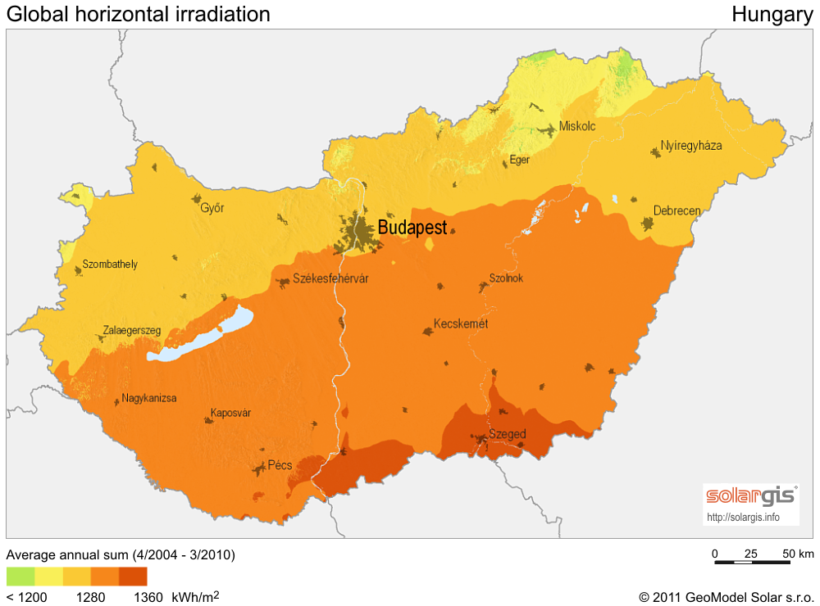

Fig. 9: Global horizontal irradiation incident on optimally inclined south-oriented PV modules in kWh/m2 for the territory of Hungary. (Source: http://solargis.info/doc/_pics/freemaps/1000px/ghi/SolarGIS-Solar-map-Hungary-en.png)

## THE SOLAR FEATURES OF SERBIA

**Solar energy potential**

The average solar radiation in Serbia is about 30% higher than the European average, but the use of solar energy for electricity generation is far behind the EU states. The economic incentives are of great importance in creating conditions for development and functionality of solar energy production, and for the safety of the PV energy market.

The annual average radiation intensity reaches 1,400 kWh/m2, and 1,700 kWh/m2 in the south-eastern parts of the country (Fig. 10). The lowest measured values of solar radiation in Serbia are comparable to the highest values in the leading countries in solar utilization such as Germany and Austria (average 1,000 kWh/m2). Average daily energy of global radiation for flat surfaces during winter ranges between 1.1 kWh/m² in the north and 1.7 kWh/m² in the south, and during the summer period between 5.4 kWh/m² in the north and 6.9 kWh/m² in the south. (Ministry of Science and Environmental Protection, Belgrade, 2004;).

**Policy support for solar power in Serbia**

The energy policy of Serbia was promoted in the Energy Law in 2004. Its objective, in accordance with the policy of joining the European Union, is to create a legal harmony, to establish qualitatively new conditions, and regulatory background for the development of energy production and consumer sectors. Accordingly, in 2005 the "Long-term development strategy of the Serbian energy sector by 2015" was adopted, and in 2007, the "Program to achieve the strategy by 2012”, which sets the strategic objectives of the country until 2030. (www.jeffersoninst.org/)

So far, utilization of RES in Serbia is limited to micro and mini hydro-power-plants. It must be outlined that the country has great unexploited production possibilities in the field of renewable energy sources (biomass and biogas, geothermal energy potential, wind energy, unused hydropower potential, solar sources).

72% of electricity is produced by traditional fossil energy sources (mainly coal), the remaining 28% is generated with hydropower plants. The proportion of RES – except hydropower – is less than 1%. Despite of the great natural potentials for unconventional energy sources, and the incentive measures of the government, a development in the production with RES cannot be experienced in Serbia. The wind, solar and biomass resources are not exploited for the production of thermal energy and electric power, and neither are the geothermal resources (Serbia is rich in geothermal features).

The country has a higher number of sunny hours than any other European country (more than 2,200 hours per year). Unfortunately, this shows that the high number of sunny hours and the high intensity values are not enough for the solar energy production to have a more significant role.

There are several solar collector system networks in Serbia. These satisfy mainly the local demands by thermal and PV production (independent supply), and only a small proportion of the produced energy is transferred into the supply system. (Dusan Z. D., 2011)

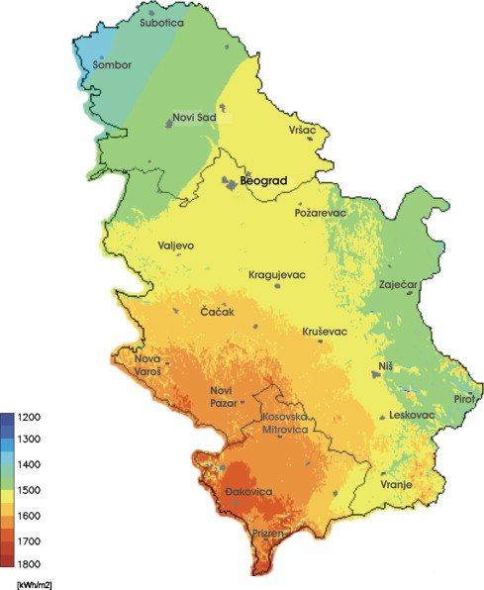

Fig. 10: Yearly sum of total solar irradiation incident on optimally inclined south-oriented PV modules in kWh/m2 for the territory of Serbia. (Source: http://ec.europa.eu)

## THE SOLAR FEATURES OF SLOVAKIA

The electricity production of Slovakia is built mainly on hydropower and nuclear plants, and thermal stations with coal, natural gas and oil. The proportion of renewable energy sources is insignificant, hydropower being the most important one.

The Slovak Republic is situated between latitudes 48 and 50. Solar radiation flux achieves a maximum of 1,050 kWh/m² per year, the maximum flux in the winter is of 80 kWh/m2, which is a low value (Fig 11). PV energy has been given little attention in Slovakia so far. This is reflected by the negligible national RTD&D activities, and the near-zero installed power. Some parts of the country have the proper feature for PV energy production, but this would require a significant support from the government in order for solar energy to become part of the Slovakian electric power energy production. In case of realization of these objectives, and by similar solar energy and consumer energy prices, solar energy would become a priority and its proportion would increase between 2015 and 2020 compared to its current insignificant status. (http://www.skrea.sk/)

Crystalline solar cells 10x10 cm are usually integrated into so-called solar modules and/or panels with an output of 100 - 130 W/m², which is a low efficiency indicator.

There were 40 pairs of solar panels installed by a 400 kV transmission line between Slovakia and Poland in 1998. The modules provide energy for the public lighting during the night. Every panel consists of 36 cells of 75 W each. Furthermore, passive solar systems are architectural solutions that supply the heat for the heating of internal spaces using sunrays.

(http://ebrdrenewables.com/)

The county has sufficient potential for the establishment of thermal solar energy systems for district heating purposes; however, no such investments have been implemented so far.

The electricity network of Slovakia covers 98% of the country, photovoltaic (PV) technology is a promising solution in areas that currently have no electricity supply.

Recently, the government of Slovakia set a goal to produce 10 GWh of power using PV installations by 2015. (Slovak Spectator, 2009).

Solar electricity production by means of photovoltaic modules is negligible, and constitutes less than 0.05 GWh.

This is not a statistically exact value because it relates to very small systems that are mostly not connected to the electric network, they are spread all over the country, and they use a part of the energy for local lighting and supply only a proportion of the electricity into the electric network. (http://www.euroqualityfiles.net/)

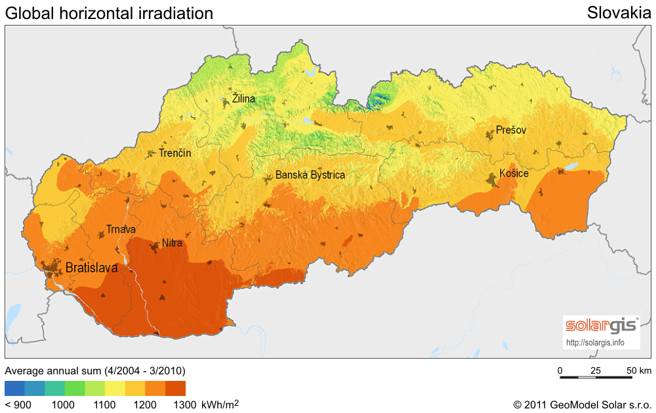

Fig. 11: Global horizontal irradiation incident on optimally inclined south-oriented PV modules in kWh/m2 for the territory of Slovakia. (Source: http://solargis.info/doc/_pics/freemaps/1000px/ghi/SolarGIS-Solar-map-Slovakia-en.png)

## THE SOLAR FEATURES OF POLAND

Solar radiation intensity in Poland is the most favourable in spring and summer months, with around 80 percent of the annual radiation intensity occurring during this period. Practically, there is no installed solar photovoltaic capacity. Despite the lack of solar installations and programs, Poland has two different sales branches for solar PV located in the country (Siemens and System PV).

Some liquid and air solar heat collectors are used in Poland. Air units are primarily used for grain drying, while liquid units are generally employed for space and hot water heating in homes and other buildings.

The estimated potential of solar energy in the country is 370 PJ/year. The annual potential solar energy values were very different, the highest being 1,340 PJ/year. This number varies greatly in different studies. It is obvious that a countrywide extensive research on the technical and economical feasibility of solar energy is needed. The map shows the global horizontal irradiation values for Poland The country has little solar resource throughout the country (Fig 12).

Although the reserves of solar energy in Poland are relatively high due to the low utilization rate, their utilisation is not easy because of high irregularity of solar radiation.

Solar energy is used to small photovoltaic installations. Solar systems (flat collectors, parabolic collectors or heliostats) heat the water for domestic purposes and the photovoltaic installations produce electricity used for supplying telecommunications devices, lighting road signs, and a few installations are used by individual investors. (Although the reserves of solar energy in Poland are relatively high, their utilisation is not easy, because of high irregularity of solar radiation. (Lidia G., et.al. 2010)

In terms of investment attractiveness and government's incentives, photovoltaic solar power is not an attractive sector for investors, since among renewable energy sources wind energy is of priority in Poland. This fact can be noted in the value of installed capacity. According to the Photovoltaics Association, by 2011 the PV investments in Poland amounted to 1.3 MW. However, the Energy Regulatory Office states that only two PV installations function and feed into the electricity network with a total capacity of 0.104 MW.

The Energy Policy of Poland forecasts that by 2020 Poland's installed PV capacity will account for 2 MW, and by 2030 this number will reach 32 MW covering 0.0622% of total electricity production in Poland. (www.evwind.es/)

Although Poland’s photovoltaic market is still in its initial phase of development, it can be observed that the Polish solar thermal market has been developing dynamically. This fast growth is accelerated by the launch of subsidies available for solar installations. After the beginning of the system, the establishment of several high-performance PV plants is expected by 2015.

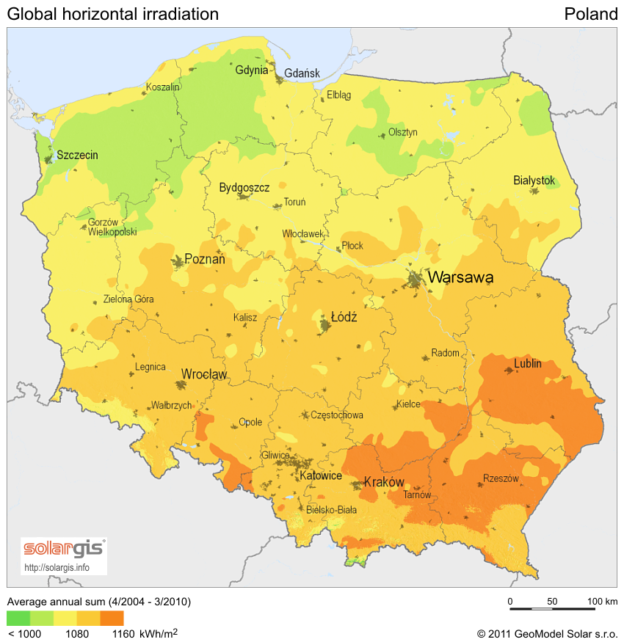

Fig 12: The global horizontal irradiation values for Poland. (Source:http://solargis.info/doc/_pics/freemaps/1000px/ghi/SolarGIS-Solar-map-Poland-en.png)

## THE SOLAR FEATURES OF MACEDONIA

There is no complete data for the solar energy potential in Macedonia; however, initial indications show promising possibilities. Use of solar energy is limited to a small number of solar water heaters.

According to the energy balance in 2006, the share of solar energy in the final energy consumption was 7.4 GWh (0.6 ktoe), or 0.04%. Macedonian factor of 8 m² solar collector footprint per 1000 inhabitants shows low utilization of solar energy. There are about 16,000 m² total area of installed flat panel solar 27 collectors for heating domestic water. The solar collectors are used in residential sector, hotels, camps, and dormitories. A residential house uses about 2-6 m² of flat solar collectors which is sufficient to meet the demand for domestic water heating. There are pilot projects where solar systems are used for space heating but their space heating capacity is limited to about 30%.

Industrial solar heating water systems are currently not used in Macedonia. There are mainly local manufacturers of solar collectors in the country. Based on the current production and the level of development there are promising possibilities for the market of solar collectors. The annual rate of growth of the local market is about 10-15%, but much larger for export.

The average domestic payback time is 6-7 years. However, several issues need to be resolved as indicated by manufacturers. These are as testing/certification/labelling of solar collectors (solar key mark) in order to protect the market from bad quality solar collectors, and to provide training to installers for their proper installation.

The Government has lowered the VAT rate for solar collectors from 18% to 5%. However, the VAT reduction applies only to the solar collector, which represents about 20% of the cost for the entire system, and therefore does not provide sufficient incentive for their purchase. PV solar energy is still 300-500% more expensive than alternative fossil fuel derived sources for production of electricity. However, given the high preferential feed-in price of 46 €cents/kWh for installed capacity of maximum 50 kW, PVs are considered a safe investment. In June 2009, the first PV plant with a capacity of 10.2 kW was commissioned by a private investor nearby Skopje. (http://macedonia.usaid.gov/)

Solar radiation in FYR Macedonia as well as in Serbia, Slovenia, Croatia and Bosnia/Herzegovina are amongst the highest in Europe. Macedonia has a potential to produce 10 GWh of solar energy per year (Colovic, 2008).

The most favourable areas record a large number of sunshine hours. The yearly ratio of actual irradiation to the total possible irradiation reaches approximately 50 percent for former Yugoslavia as a whole. This ratio is approximately 45 percent for the mountainous central regions due to the prevailing weather pattern.

The primary form of solar energy and technology used are flat plate collectors for heating houses and some commercial and public premises. However, their contribution to the total energy consumption is insignificant (less than 1 percent). Additionally, it is not expected that this figure will increase substantially in the near future, as new consumption could mainly come from new entrants to the market i.e. of new buildings or installations.

Likewise, electricity production from solar photovoltaic sources will be restricted to research or remote locations, primarily for telecommunications. This is due to the difficult economics for photovoltaics.

The following figures display the direct normal and global horizontal irradiation values for FYR Macedonia. Macedonia has great solar resource in the western portion of the country. The rest of the country could also be well suited for utilizing solar potential.

The huge solar energy potential with 2000 - 2400 sunny hours during the year and generation potential of around 10GWh per year can satisfy at least 75-80 percent of the annual needs for heating and for hot water. (Fig 13) Currently its usage is limited to water heating. In Macedonia there are only 7.5m² solar panels on every 1,000 people, or 15,000m² installed solar panels. At the end of 2006 the total collector area in operation in Macedonia was 17,118 m². From 500,000 households in Macedonia only 2500 – 3000 are using solar systems for water heating. This represents only 0.5 % of the total market for solar panels. ([www.analyticamk.org/](http://www.analyticamk.org/))

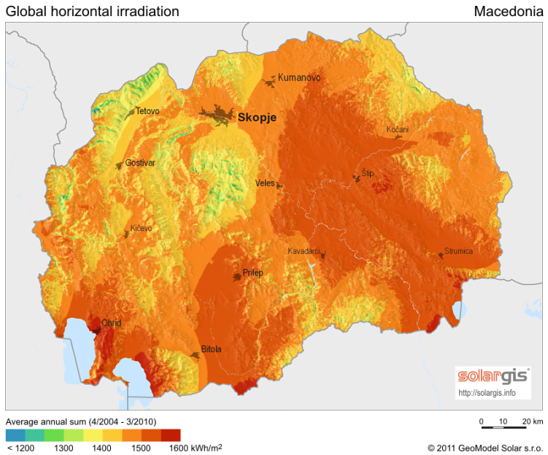

Fig. 13: Global horizontal irradiation incident on optimally inclined south-oriented PV modules in kWh/m2 for the territory of Macedonia. (Source: http://solargis.info/doc/_pics/freemaps/1000px/ghi/SolarGIS-Solar-map-Macedonia-en.png)

## THE SOLAR FEATURES OF ITALY

Photovoltaic energy production is one of the most promising renewable energy sources in Italy due to its geographical situation and the related government measures. The PV technology for energy production is widespread in the country. A significant capacity increase was experienced in 2009, Italy becoming taking the second in Europe from the point of view of solar energy utilization. This sector is currently the most attractive one for investors due to the high natural potential (Fig. 14), the economic and legal environment, and the financial support conditions.

Italy ranked among the world’s largest producers of electricity from solar power with an installed photovoltaic nameplate capacity of 12,750 MW at the end of 2011 and 263,594 plants in operation at the end of 2011. Tendencies show that photovoltaic capacities tripled in 2010, and quadrupled in 2011. The total energy produced by solar power in 2011 was 10,730 GWh, while only 1,900 at the beginning of 2010. Annual growth rates were fast in recent years: 250% in 2009 and 180% in 2010 (Table 3).

The Montalto di Castro Photovoltaic Power Station is the largest photovoltaic power station in Italy, in Montalto di Castro in Viterbo province. The project was built in several phases. The first phase with a total capacity of 24 MW was connected in late 2009. The second phase (8 MW) was commissioned in 2010, and the third and fourth phases, totalling 44 MW, were completed at the end of 2010.

As of the end of 2010, there were around 156,000 solar PV plants, with a total capacity of 3,470 MW. More than a fifth of the total production in 2010 came from the southern region of Apulia.

The Archimede solar power plant is a concentrated solar power plant at Priolo Gargallo near Syracuse. The plant was inaugurated on 14 July 2010. It is the first concentrated solar power plant to use molten salt for heat transfer and storage, which is integrated with a combined-cycle gas facility.

|  |  |  |
| --- | --- | --- |
| **PV installed capacity by year** | | |
| **Year** | **Capacity (MW)** | **Growth** |
| 2007 | 87 | 100.4% |
| 2008 | 432 | 396.55% |
| 2009 | 1,144 | 164.81% |
| 2010 | 3,470 | 203.32% |
| 2011 | 12,750 | 267.44% |

Table 3: PV installed capacity by year in Italy

Despite the favourable development conditions in Italy, solar energy to present has not been exploited adequately, some regions have unexploited potentials.

The solar heat industry reached a total turnover of approximately 200 million euro in Italy in 2007, creating more than 2,000 jobs. Solar heat production for the electricity network is not yet practiced. The most regions use solar energy for the production of hot water. The energy market is spreading towards the northern and southern part of the country very slowly.

The solar energy market is delayed compared to other EU countries. The costs of electricity generated with solar energy are by far the highest among the renewable sources, from the economic point of view, this technology is still not usually competitive.

According to the most recent data of the Manager Electric Services in Italy, in 2007 there were 8,000 plants operating for a total capacity of 83 MW. The solar cells are partially imported and partially supplied by Italian producers, such as Eurosolare and Helios Technology.

A first stimulus for the use of renewable energy sources came in 2007. Measures were taken for the support of green energies. The decisions taken make investments related to solar energy plants advantageous.

Despite these incentives, the immense potential of the exploitation of solar energy is obvious but until now has remained far behind the optimum exploitability.

The reason for that is that the first incentive measures were taken only in 2007, and an additional period had to pass until the entrepreneurial system and especially the banking and administrative systems understood its operation.

Despite these factors, the objective is the operation of photovoltaic installations totalling 3000 MW by 2016, resulting in a growth of 30% per year for photovoltaic energy and 35% for solar heat within the country. (<http://www.italchamber.se/>)

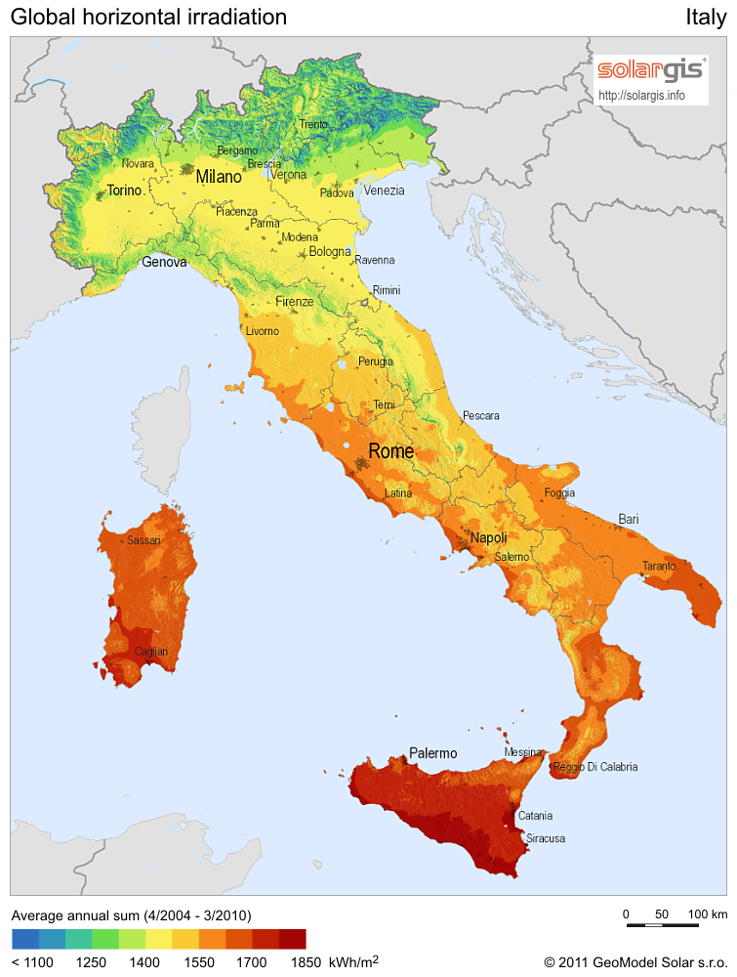

Fig. 14: Global horizontal irradiation incident on optimally inclined south-oriented PV modules in kWh/m2 for the territory of Slovakia. (Source: http://solargis.info/doc/_pics/freemaps/1000px/ghi/SolarGIS-Solar-map-Italy-en.png